**Explanation of code dialysis survival analysis:**

**1.Loading the Data**



**Purpose**: Load the dataset from a CSV file into a pandas DataFrame. This data contains information about patients on dialysis, including their age, disease type, dialysis duration, and survival status.

**2. Data Exploration**

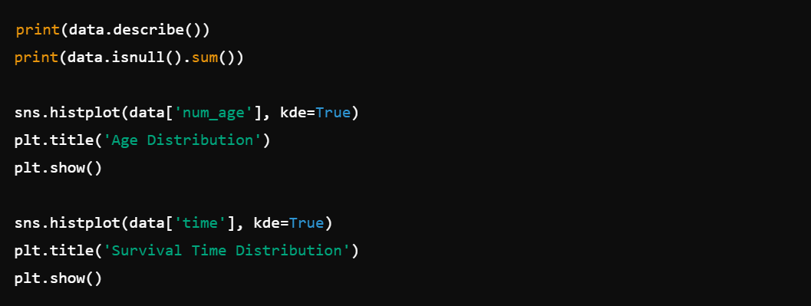

**Purpose**: Before any analysis, it's crucial to explore the data to understand its characteristics.

* **Summary Statistics**: data.describe() provides basic statistics like mean, standard deviation, min, and max for each numeric column.
* **Missing Values**: data.isnull().sum() checks if there are any missing values that need to be addressed.
* **Visualizations**: Histograms for age and survival time help visualize the distribution of these variables.

**3. Handling Missing Data**

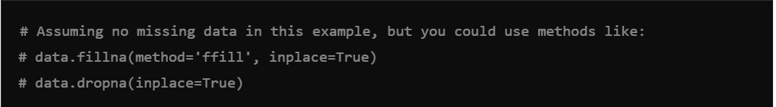

**Purpose**: If there are missing values, you must handle them to ensure the model performs well.

* **Forward Fill**: This technique fills missing data with the last valid observation.
* **Drop Missing Data**: Alternatively, rows with missing values can be dropped.

**4.One-Hot Encoding of Categorical Variables**

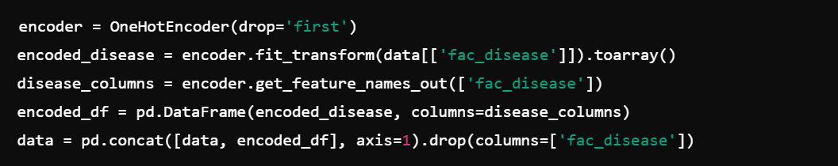

**Purpose**: Convert the categorical fac_disease column (which indicates the type of disease) into a format suitable for modeling.

* **One-Hot Encoding**: This process creates new binary columns for each category (hypertension, diabetes, renal, others). For example, fac_disease_diabetes will be 1 if the patient has diabetes, otherwise 0.
* **Avoiding Collinearity**: By using drop='first', we drop one category to prevent issues with multi collinearity in the Cox model.

**5.Feature Scaling**

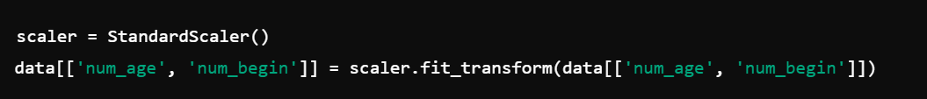

**Purpose**: Standardize the numerical features (age and months since dialysis began) to have a mean of 0 and a standard deviation of 1. This helps in making the model coefficients more interpretable and can improve the model's performance.

* **Standard Scaler**: This scaling method ensures that the numerical features are on the same scale, which is important for many machine learning models.

**6. Train/Test Split**



**Purpose**: Split the data into training and testing sets.

* **Training Set**: Used to train the model.
* **Testing Set**: Used to evaluate the model’s performance on unseen data.
* **Test Size**: 20% of the data is used for testing, while 80% is used for training.

**7.Fitting the Cox Proportional Hazards Model**

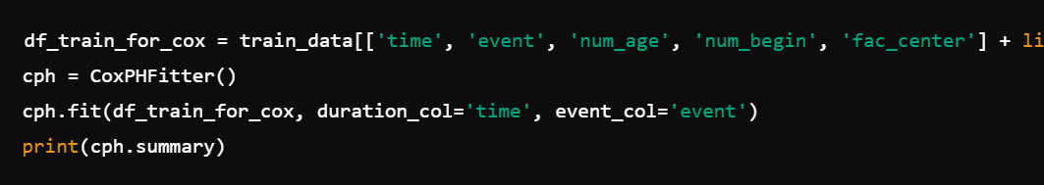

**Purpose**: Fit the Cox proportional hazards model to the training data.

* **Cox Model**: A regression model used in survival analysis to relate the survival time of patients to several predictor variables.
* **Model Summary**: The summary output provides coefficients for each variable, indicating how they influence the hazard (risk of the event occurring).

8. **Model Validation using Cross-Validation**

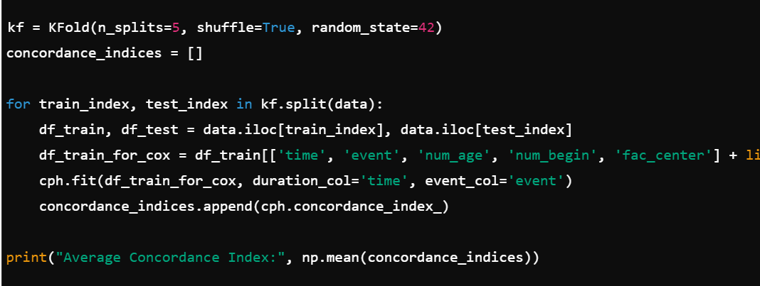

**Purpose**: Validate the model using 5-fold cross-validation.

* **K-Fold Cross-Validation**: The data is split into 5 subsets. The model is trained on 4 subsets and tested on the remaining subset. This is repeated 5 times, with a different subset used for testing each time.
* **Concordance Index**: Measures the predictive accuracy of the model. The average concordance index across all folds gives an estimate of the model's performance.

**9. Predict Survival Probabilities on Test Data**

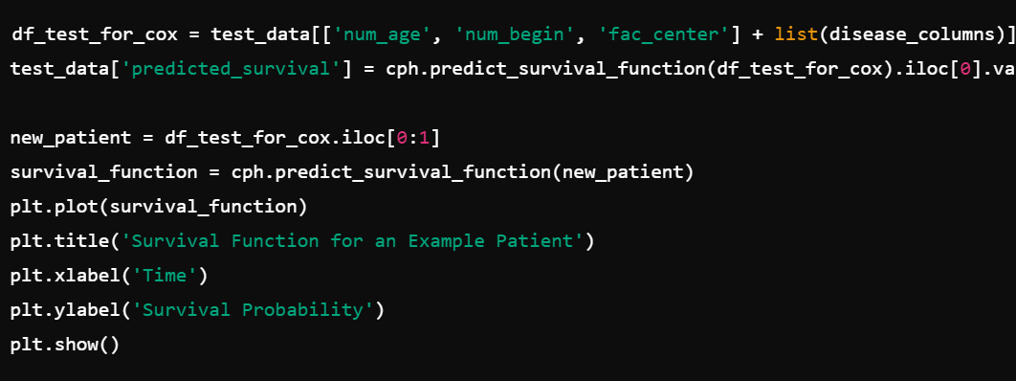

**Purpose**: Predict the survival probabilities for the patients in the test set.

* **Predict Survival Function**: For each patient, the model predicts the survival probability over time.
* **Visualization**: The survival function of an example patient is plotted to show how their probability of survival changes over time.

**10.Comparison with Kaplan-Meier Estimator**

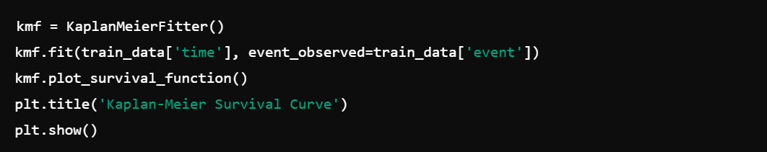

**Purpose**: Compare the Cox model's results with the Kaplan-Meier estimator, a non-parametric method used to estimate the survival function.

* **Kaplan-Meier Curve**: Plots the probability of survival over time for the entire dataset. It’s useful for understanding the overall survival trend in the data.

**11.Model Interpretation**

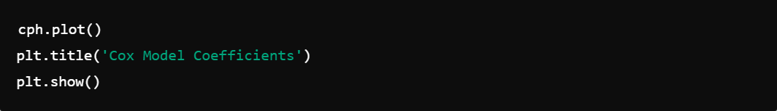

**Purpose**: Interpret the results of the Cox model.

* **Coefficient Plot**: Visualize the coefficients from the Cox model, which indicate the strength and direction (positive or negative) of the effect each variable has on the hazard (risk of the event occurring).

12. **Saving and Deploying the Model**

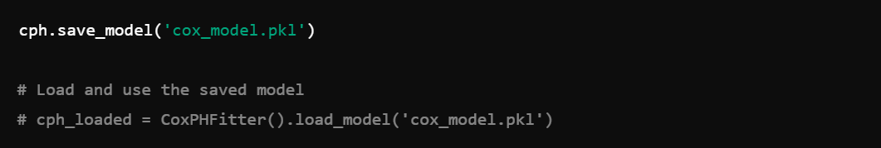

**Purpose**: Save the trained model so it can be used later without retraining.

* **Model Saving**: The model is saved to a file (`cox_model.pkl`) for future use.
* **Model Loading**: The saved model can be loaded to make predictions without retraining.

**Note: this is not any official document I made it for shayan to easily understand it and explain it to his supervisor**